Solutions to
Wireshark Lab - 3: ARP
Part I

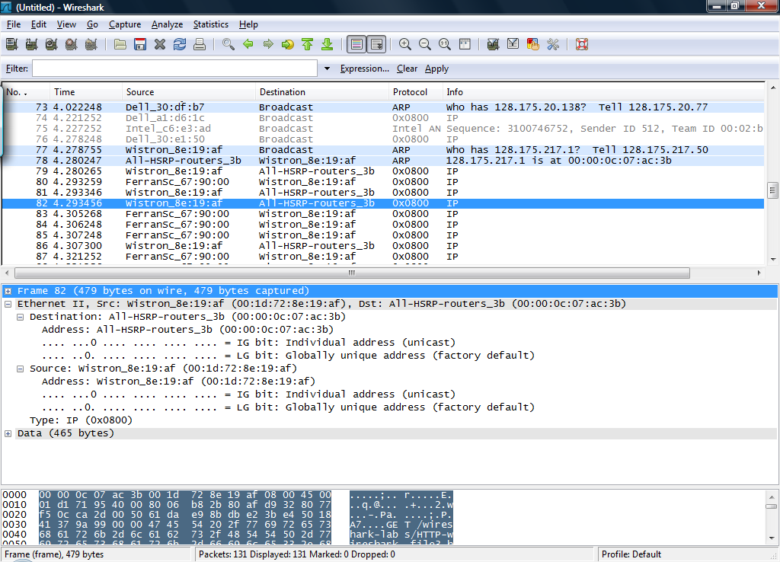

The HTTP GET Packet Number is 82
- What is the 48-bit Ethernet address of your computer?

The 48-bit address of my computer is 00:1d:72:8e:19:af

- What is the 48-bit destination address in the Ethernet frame? Is this the Ethernet address of gaia.cs.umass.edu? What device has this as its Ethernet address?

The 48-bit address of the destination is 00:00:0c:07:ac:3b. This is not the Ethernet address of gaia.cs.umass.edu. The router to which my computer is connected has this Ethernet address.

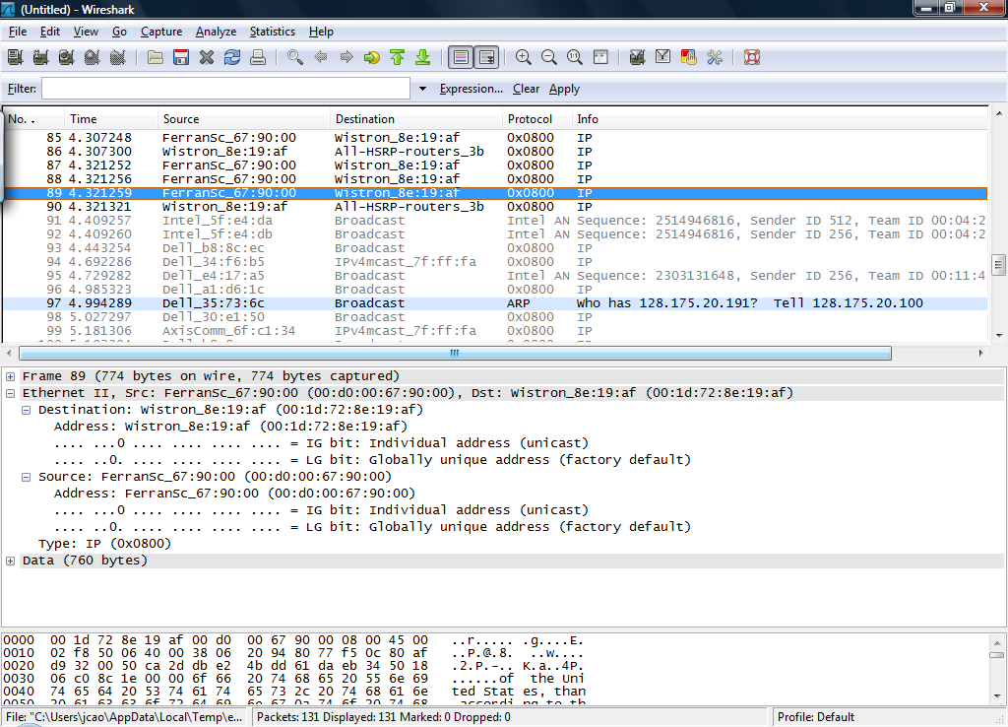

The HTTP Response Packet Number is 89

- What is the value of the Ethernet source address? Is this the address of your computer, or of gaia.cs.umass.edu? What device has this as its Ethernet address?

The source Ethernet address is 00:d0:00:67:90:00. This is not the Ethernet address of gaia.cs.umass.edu. The router to which my computer is connected has this Ethernet address.
Note: Although both Ethernet address of Question 2 and 3 correspond to the local router, they are different as they could be from different interfaces of the router (or two different routers, one for incoming traffic and the other for outgoing traffic).

4. What is the destination address in the Ethernet frame? Is this the Ethernet address of your computer?

The 48-bit address of destination is 00:1d:72:8e:19:af. This is the Ethernet address of my computer.

Part II

- Write down the contents of your computer’s ARP cache. What is the meaning of each column value?

The columns of the ARP table are the IP address, the Ethernet address and the entry type. The entry type specifies whether the entry was created dynamically or set statically.

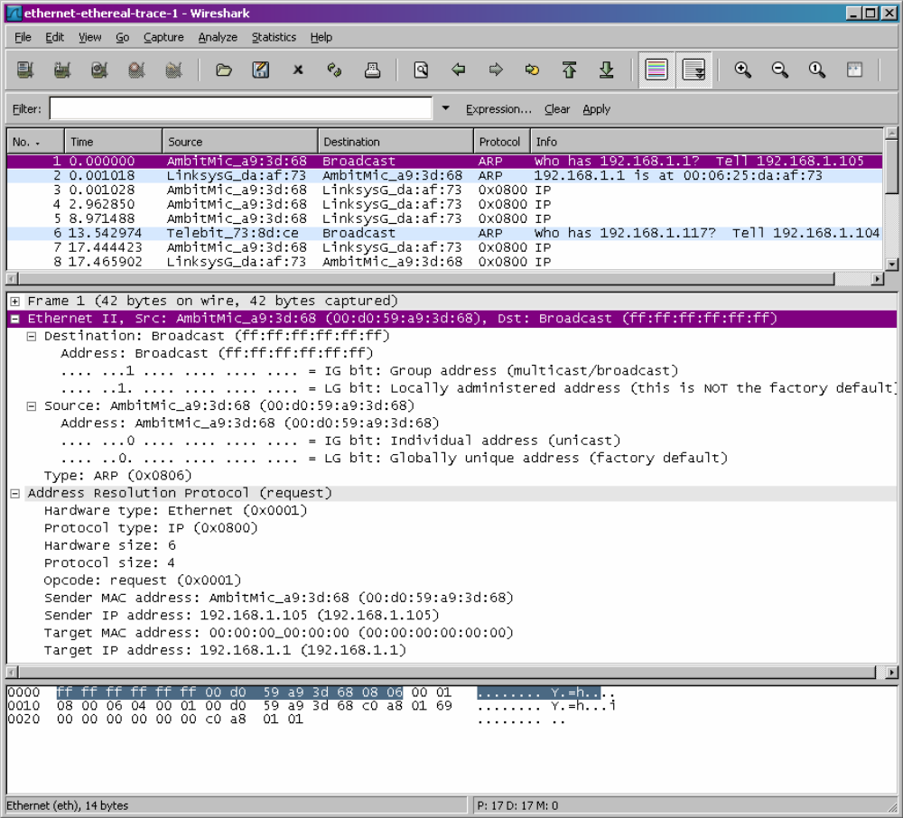

- How many ARP messages do you capture? How do you determine which ARP messages are sent from and to your computer? Why can you see ARP messages sent to other computers?
There were 3 ARP messages captured.
The messages whose source address corresponds to my computer are the ones
sent from this computer.
The messages whose destination corresponds to my computer are replies sent to
my computer.
Messages sent from other computers are visible as they are broadcast on the
network.

- What are the hexadecimal values for the source and destination addresses in the Ethernet frame containing the ARP request message?
Source address is 00:d0:59:a9:3d:68.
Destination address is ff:ff:ff:ff:ff:ff (broadcast)

- Does the ARP message contain the IP address of the sender?
Yes, ARP message contains the IP address of sender as 192.168.1.105.

- Where in the ARP request does the “question” appear – the IP address of the machine whose corresponding Ethernet address is being queried?

The target IP address and target MAC address in the ARP message indicate that the message constitutes a request for MAC address.

- What are the hexadecimal values for the source and destination addresses in the Ethernet frame containing the ARP reply message?
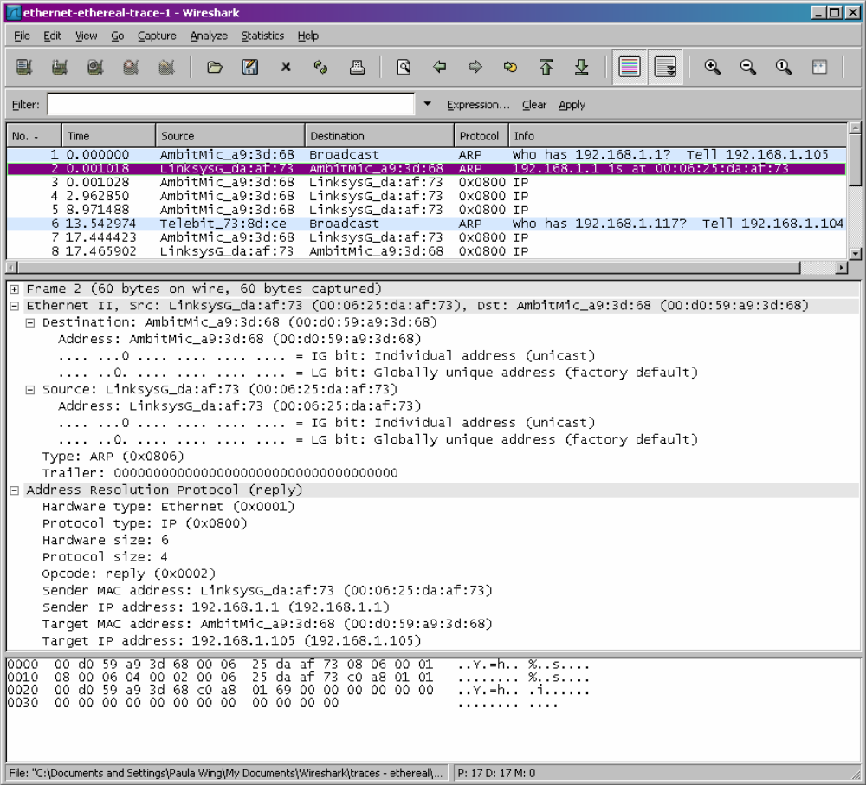
Source address is 00:06:25:da:af:73
Destination Address is 00:d0:59:a9:3d:68

- Where in the ARP message does the “answer” to the earlier ARP request appear – the Ethernet address of the machine having the IP address whose corresponding Ethernet address is being queried?
The sender IP address and sender MAC address in the ARP message indicate that the message constitutes an answer for MAC address.

- Open the ethernet--ethereal-trace- trace file in http://gaia.cs.umass.edu/ethereallabs/ethereal-traces.zip. The first and second ARP packets in this trace correspond to an ARP request sent by the computer running Wireshark, and the ARP reply sent to the computer running Wireshark by the computer with the ARP-requested Ethernet address. But there is yet another computer on this network, as indicated by packet 6 – another ARP request. Why is there no ARP reply (sent in response to the ARP request in packet 6) in the packet trace?

If we examine the source address of the packet, we see that the packet was not sent by computer running Wireshark. The request packet was just received because it was broadcasted on the network. The reply would be unicasted by the sought computer to the sender. Hence it was not received by the computer running Wireshark.

